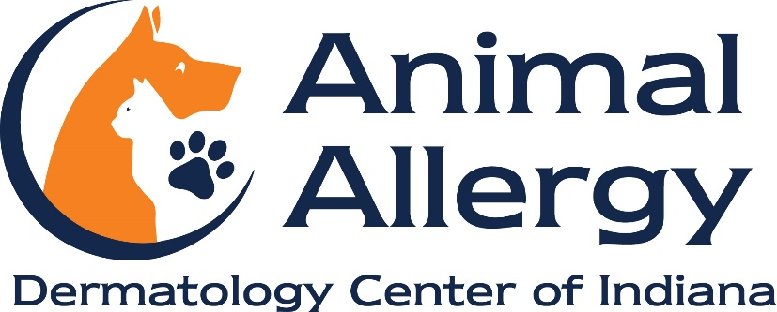

Public Notice of our COVID-19 Safeguard Plan
Animal Allergy & Dermatology Center of Indiana has implemented the following procedures to maintain a safe environment for our employees and clients as requires by Executive Order and IOSHA:
Employee Health Screenings:
●employees are required to take their temperature at home prior to their scheduled shift
●employees are expected to contact management prior to their scheduled shift if they have a fever and/or if they are experiencing any COVID-19 symptoms such as cough, shortness of breath, fever, chills, muscle pain, sore throat, new loss of taste or smell, nausea, vomiting or diarrhea and not report to work
●employees are expected to notify management if they have been exposed or been in contact with a person known to be positive for COVID-19

Client Expectations:
●Clients should not come to their scheduled appointment or pick up medication for their pet if they have been exposed to COVID-19 or if they have shown symptoms of the virus. The appointment can be rescheduled, or the pet should be brought to the clinic by a healthy relative or friend

Enhanced Cleaning and Disinfecting Protocols:
●All workstations, keyboards, doorknobs, countertops and other “high touch” surfaces will be cleaned regularly by employees
●All surfaces in exam rooms, stethoscopes and other tools will be cleaned between uses
●We use Personal Protective Equipment (PPE) responsibly for all procedures where required and clean all reusable PPE regularly
●Clients and employees are encouraged to wash their hands in the designated areas. We strive to have hand sanitizer and tissues available for public use if supplies permit

●Remember to:
- wash your hands with soap and water for at least 20 seconds as frequently as possible
-use hand sanitizer when available
-cover coughs and sneezes (into the sleeve or elbow, not hands)
-do not shake hands

Social Distancing Requirements:
●Employees and clients are required to maintain a six-foot distance from each other as often as possible
●Employees and clients are encouraged to wear a face mask or covering at all times
●Please try to limit the number of people who come to your pet’s appointment to 2 people
●We offer direct admission for clients and patients to exam rooms from their cars, rather than from the lobby (starting June 1st tentatively)
●We offer car-side appointments for those clients who wish to remain outside while their pet is examined inside
●We offer curbside delivery of medication refills and veterinary diets

These policies are subject to change per the need of Animal Allergy & Dermatology Center of Indiana and to comply with all orders, opinions and regulations from federal, state or local government or administrative agencies, including Executive Orders and IOSHA requirements.

